A Project Report on
Fine-grained Abnormal Driving Behaviors
Detection and Identification with Smartphones
Submitted by:
U.SRI DEVI 148T1A0597
A.RAKESH 148T1A0569
K.MURALIDHAR 158T5A0503
K.SRI SATYA HARSHA 148T1A0599
V.SUSMITHA 148T1A05A6
Under the guidance of
Dr. B. Srinivasa Rao
Professor & HOD
In partial fulfillment for the award of the degree
Of
BACHELOR OF TECHONOLOGY
IN
COMPUTER SCIENCE AND ENGINEERING

DHANEKULA INSTITUTE OF ENGINEERING AND TECHNOLOGY
(Affiliated To JNTUK, Kakinada, Andhra Pradesh (India)
GANGURU, AP, INDIA - 521139

2017-18

DHANEKULA INSTITUTE OF ENGINEERING & TECHNOLOGY
(Affiliated to Jawaharlal Nehru Technological University, Kakinada)
Ganguru, Vijayawada– 521139
ANDHARA PRADESH, INDIA
DEPARTMENT OF COMPUTER SCIENCE AND ENGINEERING



CERTIFICATE
This is to certify that the project titled “Fine-Grained Abnormal Driving Behaviors Detection and Identification with Smartphones” is the bonafide work carried out by U.SRI DEVI (148T1A0597), A.RAKESH (148T1A0569), K.MURALIDHAR (158T5A0503), K.SRI SATYA HARSHA (148T1A0599),V.SUSMITHA (148T1A05A6) in partial fulfillment for the award of the degree of BACHELOR OF TECHNOLOGY in Jawaharlal Nehru Technological University Kakinada during the academic year 2017-18

Project guide HOD
Dr.B.SRINIVASA RAO Dr.B.SRINIVASA RAO

External Examiner

DECLARATION BY THE CANDIDATES

I hereby declare that the project entitled “Fine-Grained Abnormal Driving Behaviors Detection and Identification with Smartphones” submitted for the B. Tech. (CSE) degree is my original work and the project has not formed the basis for the award of any other degree, diploma, fellowship or any other similar titles.

U. Sri Devi (148T1A0597)

A. Rakesh (148T1A0569)

K. Muralidhar (158T5A0503)

K. Sri Satya Harsha (148T1A0599)

V. Susmitha (148T1A05A6)

ABSTRACT
Real-time abnormal driving behaviors monitoring is a corner stone to improve driving safety. To improve awareness of drivers’ driving habits and to prevent potential car accidents, we need to consider a fine-grained monitoring approach, which not only detects abnormal driving behaviors but also identifies specific types of abnormal driving behaviors, i.e. Weaving, Swerving, Side slipping, Fast U-turn, Turning with a wide radius and Sudden braking. Through empirical studies we found that all the six types of driving behaviors have their unique patterns on acceleration and orientation. Recognizing this observation, we proposed a fine-grained abnormal Driving behavior Detection and iDentificationsystem, D3, to perform real-time high-accurate abnormal driving behaviours monitoring using Smartphone. We extract effective features to capture the patterns of abnormal driving behaviours. After that, machine learning method, Support Vector Machine (SVM) is employed respectively to train the features and output a classifier model which conducts fine-grained abnormal driving behaviours detection and identification.

PO’s and PSO’s mapping:

Course Outcomes vs PO_{S}*Mapping:
Courses Out Comes | P01 | P02 | P03 | P04 | P05 | P06 | P07 | P08 | P09 | P10 | P11 | P12
R13C414.1 | 3 | 3 | 3 | 3 | 3 | 3 | 3 | 2 | 3 | 3 | 2 | 2
R13C414.2 | 3 | 3 | 3 | 3 | 3 | - | 2 | 2 | 3 | 3 | 2 | 2
R13C414.3 | 3 | 3 | 3 | - | 2 | - | - | 2 | 3 | 2 | 3 | 2
R13C414.4 | 3 | 3 | - | - | 2 | - | - | 2 | - | 3 | - | -
R13C414.5 | 3 | 3 | - | - | 3 | - | - | 2 | - | 3 | - | 1
R13C414.6 | 3 | 3 | 3 | - | 2 | - | - | 2 | 2 | - | - | 2
Total | 18 | 18 | 12 | 6 | 15 | 3 | 5 | 12 | 11 | 14 | 7 | 9
Average | 3 | 3 | 3 | 3 | 2 | 3 | 2 | 2 | 3 | 3 | 2 | 2

Course Outcomes vs. PSOs Mapping:
Courses Out Comes | PSO1 | PSO2
R13C414.1 | 3 | 2
R13C414.2 | 3 | 2
R13C414.3 | 3 | 2
R13C414.4 | 2 | 2
R13C414.5 | 3 | 2
R13C414.6 | 3 | 2
Total | 17 | 12
Level of mapping | 3 | 2

3 – Strong Correlation, 2- medium Correlation, 1- Low Correlation
Average: 0-6: treated as 1 7-12: treated as 2 13-18: treated as 3

Acknowledgement
The satisfaction that accompanies that the successful completion of any task would be incomplete without the mention of people whose ceaseless cooperation made it possible, whose constant guidance and encouragement crown all efforts with success. We express our deep sense of gratitude to our respected guide Dr.B.Srinivasa Rao and for his valuable guidance, throughout the project.
We extend our sincere thanks to our B.Tech project Co-Ordinator Mrs.L.N.B.Jyotsna Naga Baby, the Head of the Department Dr.B.Srinivasa Rao and to all of the faculty members of Computer Science and Engineering in Dhanekula Institute of Engineering & Technology for their kind co-operation and help in our academic education.
We are also grateful to respected Dr .Ravi Kadiyala, Principal and the Management of Dhanekula Institute of Engineering & Technology for motivating and providing us adequate facilities without which project would not have seen of the light of the day

Lastly, we would like to express our deep appreciation towards our classmates and our indebtedness to our parents for providing us the moral support and encouragement.

U. Sri Devi (148T1A0597)

A. Rakesh (148T1A0569)

K. Muralidhar (158T5A0503)

K. Sri Satya Harsha (148T1A0599)

V. Susmitha (148T1A05A6)

Table of Contents
CONTENTS Page no
Title page i
Certificate of the guide ii
Declaration iii
Abstract iv
PO’s & PSO’s Mappings v
Acknowledgement vi
1. Introduction 1
1.1 Problem Definition 2
1.2 Project proposal 3
1.2.1 Scope 3
2. Literature Survey 4
3. Software Requirement Analysis 7
3.1 System Requirement 8
3.1.1 Software Requirements 8
3.1.2 Hardware Requirements 8
3.2 System Analysis 8
3.2.1 Requirement Analysis 8
3.2.2 Functional Modules 10
3.2.3 Module Information & Specification 10
4. System Design 12
4.1 About System Design 13
4.2 System Architecture 13
4.3 UML Modeling 14
4.4 Object Oriented Design 19
4.4.1 Class Diagram 19
4.4.2 Use case Diagram 20
4.4.3 Sequence Diagram 21
4.4.4 Collaboration Diagram 22
4.4.5 Activity Diagram 22
4.4.6 Data Flow Diagram 23
5. System Development Environment 24
6. Sample code 28
7. System Testing 32
7.1 Introduction 33
7.2 Level of Testing 33
7.3 Testing Strategies 34
8. Screen Shots 38
9. Conclusion 45
10. Future Scope 47
11. Bibliography 49

LIST OF FIGURES
Fig No. | Fig Name | Page No.
Figure 4.1 | System Architecture | 13
Figure 4.2 | Class Diagram | 19
Figure 4.3 | Use Case Diagram | 20
Figure 4.4 | Sequence Diagram | 21
Figure 4.5 | Collaboration Diagram | 22
Figure 4.6 | Activity Diagram | 22
Figure 4.7 | Data Flow Diagram | 23
Figure 5.1 | Android Architecture | 25
Figure 8.1 | Application Preview | 39
Figure 8.2 | Overview of application | 40
Figure 8.3 | Analysis Phase | 41
Figure 8.4 | Result of analysis phase | 42
Figure 8.5 | Automatic phase | 43
Figure 8.6 | Result of automatic phase | 44

INTRODUCTION

1. Introduction
1.1. Problem Definition:
According to the statistics from World Health Organization (WHO), traffic accidents have become one of the top 10 leading causes of death in the world. Specifically, traffic accidents claimed nearly 3500 lives each day in 2014.Studies show that most traffic accidents are caused by human factors, e.g. drivers’ abnormal driving behaviors. Therefore, it is necessary to detect drivers’ abnormal driving behaviors to alert the drivers or report Transportation Bureau to record them.
Although there has been works on abnormal driving behaviors detection, the focus is on detecting driver’s status based on pre-deployed infrastructure, such as alcohol sensor, infrared sensor and cameras, which incur high installation cost. Since smartphones have received increasing popularities over the recent years and blended into our daily lives, more and more smartphone-based vehicular applications are developed in Intelligent Transportation System. Driving behavior analysis is also a popular direction of smartphone-based vehicular applications. However, existing works on driving behaviors detection using smartphones can only provide a coarse result using thresholds, i.e. distinguishing abnormal driving behaviors from normal ones. Since thresholds may be affected by car type and sensors’ sensitivity, they cannot accurately distinguish the differences in various driving behavioural patterns. Therefore, those solutions cannot provide fine-grained identification, i.e. identifying specific types of driving behaviours.
Moving along this direction, we need to consider a fine-grained abnormal driving behaviors monitoring approach, which uses smartphone sensors to not only detect abnormal driving behaviors but also identify specific types of behaviors without requiring any additional hardwares. The fine-grained abnormal driving behaviors monitoring is able to improve drivers’ awareness of their driving habits as most of the drivers are over-confident and not aware of their reckless driving habits. Additionally, some abnormal driving behaviors are unapparent and easy to be ignored by drivers. If we can identify drivers’ abnormal driving behaviors automatically, the drivers can be aware of their bad driving habits, so that they can correct them, helping to prevent potential car accidents.
There are six types of abnormal driving behaviors defined, and they are illustrated in Fig.1. Weaving(Fig.1(a)) is driving alternately toward one side of the lane and then the other, i.e. serpentine driving or driving in S shape; Swerving (Fig.1(b)) is making an abrupt redirection when driving along a generally straight course; Side slipping(Fig.1(c)) is when driving in a generally straight line, but deviating from the normal driving direction; Fast U-turn(Fig.1(d)) is a fast turning in U-shape, i.e. turning round(180 degrees) quickly and then driving along the opposite direction; Turning with a wide radius (Fig.1(e)) is turning cross an intersection at such an extremely high speed that the car would drive along a curve with a big radius, and the vehicle sometimes appears to drift outside of the lane, or into another line; Sudden braking (Fig.1(f)) is when the driver slams on the brake and the vehicle’s speed falls down sharply in a very short period of time.
This work uses smartphone sensing and machine learning techniques. By extracting unique features from the readings of smartphone sensors, we can detect and identify the six types of abnormal driving behaviors above. To realize a fine-grained abnormal driving behaviors detection and identification, we face the following great challenges. First, patterns of driving behaviors need to be identified from readings of smartphone sensors. Second, the noise of smartphone sensors’ readings should be removed. Finally, the solution should be lightweight and computational feasible on smartphones. Based on the classifier model, we propose an abnormal Driving behaviour Detection and iDentification system, D3, which can realize a fine-grained abnormal driving behaviors detection and identification in real-time using smartphone sensors.

1.2 Project proposal:
This work uses Smartphone sensing and machine learning techniques by extracting unique features from readings of Smartphone's accelerometer and orientation sensor; we first identify the six types of abnormal driving behaviors. Then, we train those features through machine learning method Support Vector Machine (SVM) to generate a classifier model which could clearly identify each of driving behaviors (i.e. the normal driving behaviors as well as the six types of abnormal ones)
1.2.1 Scope
This project has a wide scope for development by including some extra features that is if the results of the monitoring could be passed back to a central server, they could be used by the police to detect drunken-driving automatically or Vehicle Insurance Company to analyze the policyholders’ driving habits.

LITERATURE SURVEY

2. Literature Survey:
- Nidhi Kalra et al. [2014] have studied that in today's life, everyone seems to be in hurry to achieve their destination as quickly as doable. Therefore individuals advisedly or accidentally take harsh driving events like unforeseen acceleration, unforeseen turns or unforeseen brakes that more lead them to accidents or maybe loss of their lives. And it's a typical belief that if person behaviour was being monitored, it might be comparatively safer. To watch driver behaviour numerous sensors were getting used either deployed within the automotive, wayside or inherent in Smartphone. This paper provides a survey of varied ways for analyzing driver behaviour appeared in literature survey. This paper conjointly provides some analysis directions that numerous researchers will explore. [1]
- Prarna Dhar et al. [2014] have studied the Unsafe driving primarily includes driving either headlong or driving below the Influence (DUI) of alcohol, may be a major reason for traffic accidents throughout the planet. During this paper, we advise an extremely economical system that helps at early detection and alert of dangerous vehicle manoeuvres usually associated with rash driving. The complete system needs solely an itinerant which can be placed in vehicle and with its inherent measuring system and orientation sensing element. When putting in a program on the itinerant, it'll cypher accelerations supported sensing element readings and compares them with typical unsafe driving patterns extracted from real driving tests. [2]
- Rachana Daigavane et al. [2015] has studied and discovers the most causes of accidents and so provide risk assessments. pursuit dangerous driving behavior will facilitate raise drivers awareness of their driving habits and associated risks, thus, serving to cut back careless driving and enforce safe driving practices. Showing determination behavior and energetic pursuit of your ends was presently a causal agency of traffic in an urban centre. Awareness and encourage driver safety square measure the measures that square measure further, we have a tendency to square measure shall propose a decent arrangement that uses detection system and management of the vehicle. For the foremost half, drivers aren't aware that they offer disposition to behave sharply activity found within the normal course of events. Among the factors concerned in driving, particularly the motive force, the vehicle, and also the surroundings, the human issue is that the most relevant and most troublesome to characterize. This project wasn't solely helpful for the motive force's behavior detection however conjointly offer reconstruction and investigation of accidents and during this thanks to cut back the risks and dangers for the driver. [3]
- J. Engelbrecht et al. [2015] have studied a Road crashes square measure a growing concern of governments and is rising to become one amongst the leading preventable causes of death, particularly in developing countries. The ever present presence of smartphones provides a brand new platform on that to implement sensing element networks and driver help systems, further as different ITS applications. During this paper, existing approaches of exploitation smartphones for ITS applications square measure analyzed and compared. Specific focus is on vehicle-based observance systems, like driving behaviour and elegance recognition, accident detection and road condition observance systems. More opportunities to be used of smartphones in ITS systems were highlighted, and remaining challenges during this rising field of analysis square measure known.

SOFTWARE REQUIREMENT ANALYSIS

3. Software Requirement Analysis

3.1 System Requirements

System Requirements Specifications (SRS) the requirements work product that formally specifies the system –level requirement of a single or an application. The System Requirement Specification identifies, defines and clarifies the requirement, that when satisfied through development meet the operational /functional need identified in the Project Concept Proposal, Project Business Case and Project Charter. Approval of this document constitutes agreement that the developed system satisfying these requirements will be accepted.

3.1.1 Software Requirement

One of the most difficult tasks is that, the selection of the software, once system requirements are known is determining whether a particular software package fits the requirements. This section first summarizes the application requirements questions and then suggests more detailed comparisons.

Operating system : Windows XP.
Coding Language : Java 1.6
Tool Kit : Android 3.0
IDE : Android Studio
3.1.2 Hardware Requirements
System : Pentium IV 2.4 GHz.
Hard Disk : 40 GB.
Monitor : 15 VGA Colour.
RAM : 4GB

3.2 System Analysis
System Analysis is the process of analyzing a system with potential goal of improving or modifying the system. Analysis is breaking down the problem into smaller elements for study and ultimately providing better solution. During the process of system development analysis is an important aspect. This involves to recommend improvement to the system. Ultimately, the goal is a computerized solution.
3.2.1 Requirements Analysis
We are overcoming the tedious manual procedure by this approach involving automatic report generations and provide with required information.

3.2.1.1 Functional Requirements
This section describes the functional requirements of the system for those requirements which are expressed in the natural language style.
- Collecting data
- Analyzing patterns
- Filtering data
- Sending alerts
3.2.1.2 Non Functional Requirements
- User-friendly: Customer will use the forms for their various transactions i.e. for adding new routes, viewing the routes details. Also the Customer wants the reports to view the various transactions based on the constraints. Theses forms and reports are generated as user-friendly to the Client.
- Reliability: The package wills pick-up current transactions on line. Regarding the old transactions, User will enter them in to the system.
3.2.1.3 Existing System
Although there has been works on abnormal driving behaviors detection, the focus is on detecting driver’s status based on pre-deployed infrastructure, such as alcohol sensor, infrared sensor and cameras, which incur high installation cost. Since smartphones have received increasing popularities over the recent years and blended into our daily lives, more and more smartphone-based vehicular applications are developed in Intel-ligent Transportation System. Driving behavior analysis is also a popular direction of smartphone-based vehicular applications. However, existing works on driving behaviors detection using smartphones can only provide a coarse-grained result using thresholds, i.e. distinguishing abnormal driving behaviors from normal ones. Since thresh-olds may be affected by car type and sensors’ sensitivity.

Limitations of Existing System
- They cannot accurately distinguish the differences in various driving behavioural patterns. Therefore, those solutions cannot provide fine-grained identification, i.e. identifying specific types of driving behaviors.
- They detect driver’s status based on pre-deployed infrastructure, such as alcohol sensor, infrared sensor and cameras, which incur high installation cost.
3.2.1.4 Proposed System
We need to consider a fine-grained abnormal driving behaviors monitoring approach, which uses smartphone not only to detect abnormal driving behaviors but also to identify specific types of the driving behaviors without requiring any additional hardware. The fine-grained abnormal driving behaviors monitoring improves drivers’ awareness of their driving habits as most of the drivers are over-confident and not aware of their reckless driving habits. If we can identify drivers’ abnormal driving behaviors automatically, the drivers can be made aware of their bad driving habits, so that they can correct them, helping to prevent potential car accidents
3.2.2 Functional Modules
- Collecting Data from Smartphone Sensors.
- Analyzing Patterns of Abnormal Driving Behaviors.
- Low-pass Filtering.
3.2.3 Module Information & Specification:
3.2.3.1. Collecting Data from Smartphone Sensors:
We develop an Android-based App to collect readings from the 3-axis accelerometer and the 3-axis orientation sensor. We align the two coordinate systems in the Smartphone and in the vehicle by making the accelerometer’s y-axis along the moving direction of the vehicle. Therefore, we could monitor the vehicle’s acceleration and orientation by retrieving readings from the Smartphone's accelerometer and orientation sensor.

3.2.3.2 Analyzing Patterns of Abnormal Driving Behaviors:
After high frequency noises are removed in the collected data using the low-pass filter, we can analyze the acceleration and orientation patterns of each type of abnormal driving behaviors. Let acc_{x} and acc_{y} be the acceleration on x-axis and y-axis, respectively. Let ori_{x} and ori_{y} be the orientation on x-axis and y-axis, respectively.
3.2.3.3 Low-pass Filtering:
Due to environmental dynamics, there are many high frequency noises in our collected raw data which has an impact on analyzing the dynamics of different driving behaviours. Thus we conduct low-pass filtering to the collected raw data first to remove the high frequency noise and yet capture the statistical features presented in the traces through dynamic exponential smoothing filter (DESF).

SYSTEM DESIGN

4. System Design
4.1 About System Design
Once the analysis stage is completed, the next stage is to determining in broad outline form how the problem might be solved. During system design, we are beginning to move from logical to physical level.
System design involves architectural and detailed design of the system. Architectural design involves identifying software components, decomposition them into processing modules and conceptual data structures, and specifying the interconnections among components.
4.2. System Architecture:
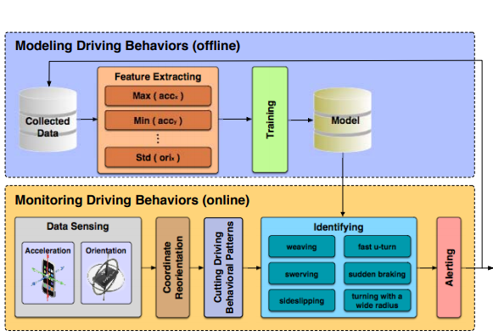
Fig.4.1 System Architecture
Fig.3.1 shows the architecture of D3. The whole system is separated into offline part-Modeling Driving Behaviors and online part Monitoring Driving Behaviors. In the offline part, Modeling Driving Behaviors, D3 trains a classifier model using machine learning techniques based on the collected data, which could identify specific types of driving behaviors. In the Feature Extracting, effective features are extracted from specific types of driving behavioral patterns on acceleration and orientation. Afterwards, the features are trained in the Training and a classifier model would be generated which can realize fine-grained identification for various types of driving behaviors. Finally, the classifier model is output and stored to Model Database. The online part, Monitoring Driving Behaviors, is installed on smartphones which senses real-time vehicular dynamics to detect and identify abnormal driving behaviors. D3 first senses the vehicles’ acceleration and orientation by smartphones’ accelerometers and orientation sensors. After getting real-time readings from the accelerometer and the orientation sensor, the Coordinate Reorientation is performed to align the smartphone’s coordinate system with the vehicle. Then, in the Cutting Driving Behavioral Patterns, the beginning and ending of a driving behavior are found out from accelerometer and orientation sensor’s readings. Afterwards, in Identifying, D3 extracts features from patterns of the driving behaviors, then identifies whether one of the abnormal driving behaviors occurs based on the classifier model trained in Modeling Driving Behaviors. Finally, if any of the abnormal driving behaviors were identified, a warning message would be sent to receivers by the Alerting.
4.3 UML Modeling
In the field of software engineering, the Unified Modeling Language(UML) is a standardized visual specification language for the Object modeling.UML is a general-purpose modeling language that includes a graphical notations used to create an abstract model of a system, referred to as a UML model. The model also contains a “Semantic backplane” documentation such as written cases that drive the model element and diagram.
Importance of UML in Modeling
A modeling language is a language whose vocabulary and rules focus on the conceptual and physical representation of a system. A modeling language such as UML is thus a standard language for software blueprints. The UML is not a visual programming language, but its models can be directly connected to various programming languages. This means that it is possible to map from a model in the UML to a programming language JAVA, C++ or Visual Basis, or even tables in relational database or the persistent store of an object oriented database. This mapping permits forward engineering: The generation of code from a UML model into programming language .
The reverse is also possible you can reconstructed a model from an implementation Back into UML. This is a programming Language that is used for object oriented software development.
To organize program code more efficiency, programmers often create ”objects” that are set of structured data within programs. UML, which has been standardized by the Object Management Group(OMG), was designed for this purpose. The language has gained enough support that it has become a standard language for visualizing and constructing software programs. The design gives the blueprint of project, so it should be done perfectly without any error. On design only all the other phases of development are present. We use UML language for it.
Basic Building Blocks of UML
The vocabulary of UML encompasses three kinds of building blocks:
1. Things
2. Relationships
3. Diagrams
Things in UML
They are the abstraction that are first-class citizens in a model. There are four kinds of things in the UML
- Structural Thing
- Behavioral Things
- Grouping Things
- Annotational Things
These things are the basic object oriented building blocks of the UML. They are used to write well-formed model.
Diagrams in UML
Diagrams are graphical representation of set of elements. Diagrams project a system , or visualize a system from different angles and perspectives.
Class Diagram
This shows set of classes, interfaces, collaborations and their relationships. There are the most common diagram in modeling the object oriented system and are used to give the static view of a system. Class are composed of three things: a name , attributes and operations.

Object Diagram
It shows a set of objects and their relationships and are used to show the data structures, the static snapshots of instances of the element in a class diagram. Like class diagram, the object diagram also address the static design view or process view of a system.
Component Diagram
It shows a set of components and their relationships and are used to illustrate the static implementation view of a system. They are related to class diagram where in components map to one or more classes, interfaces of collaborations.
Deployment Diagram
It shows a set of nodes and their relationships. They are used to show the static deployment view of the architecture of a system. They are related to the component diagram where a node encloses one or more components.
Use Case Diagram
It shows a set of use cases and actors and their relationships. These diagrams illustrate the static use case view of a system and are important in organizing and modeling the behaviors of a system.
The two main components of a use case diagram are use cases and actors.
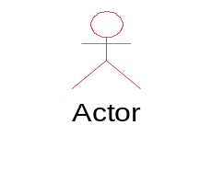
Use Case
Sequence Diagram & Collaboration Diagram
These two diagrams are semantically same i.e. the dynamics of a system can be modeled using one diagram and transform it to the other kind of diagram without loss of information. Both from the, Interaction diagram.
Sequence Diagram:
Sequence diagram is an interaction diagram which focuses on the time ordering of messages it shows a set of objects and messages exchange between these objects. This diagram illustrate the dynamics view of a system.

Collaboration Diagram:
This diagram is an interaction diagram that stresses or emphasizes the structural organization of the object that sends and receives messages. It shows a set of objects, links between objects and messages send and receive by those objects. There are used to illustrate the dynamics view of a system.
State Chart Diagram
State chart diagram shows a state machine consisting of states, transition and activities these illustrate the dynamics view of a system. They focus on the event ordered behavior of an object.
Activity Diagram
Activity Diagram shows the flow from one activity to another within a system. The activities may be sequential or branching objects that act and are acted upon.
Relationships in UML
There are different types of relationships in the UML. They are
- Dependency
- Association
- Aggregation
- Composition
- Generalization
- Realization
1.Dependency:
This is relationship between two classes whenever one class is completely dependent on the other class. Graphically the dashed line represent it with arrow pointing to the class that it is being depends on.
2. Association:
Association is a generic relationship between two classes and is modeled by a line connecting the two classes . This line also shows the feature multiplicity.
1…n owned by 1
3. Aggregation:
Aggregation indicates the whole part of relationship. It is represented by the symbol
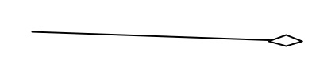
4. Composition:
Composition relationship means the class is a member of another class. It cannot be present by itself. It is represented by
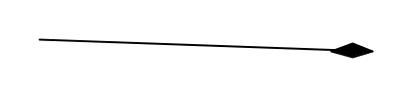
5. Generalization:
Generalization relationship means” is –a “relationship. A generalization has a triangle pointing to the super class. It is represented as

4.4 OBJECT ORIENTED DESIGN
4.4.1 CLASS DIAGRAM
This section describes the architecturally significant parts of the model, such as its decomposition into subsystem and packages, and for each significant packages, its decomposition into classes and utilities.
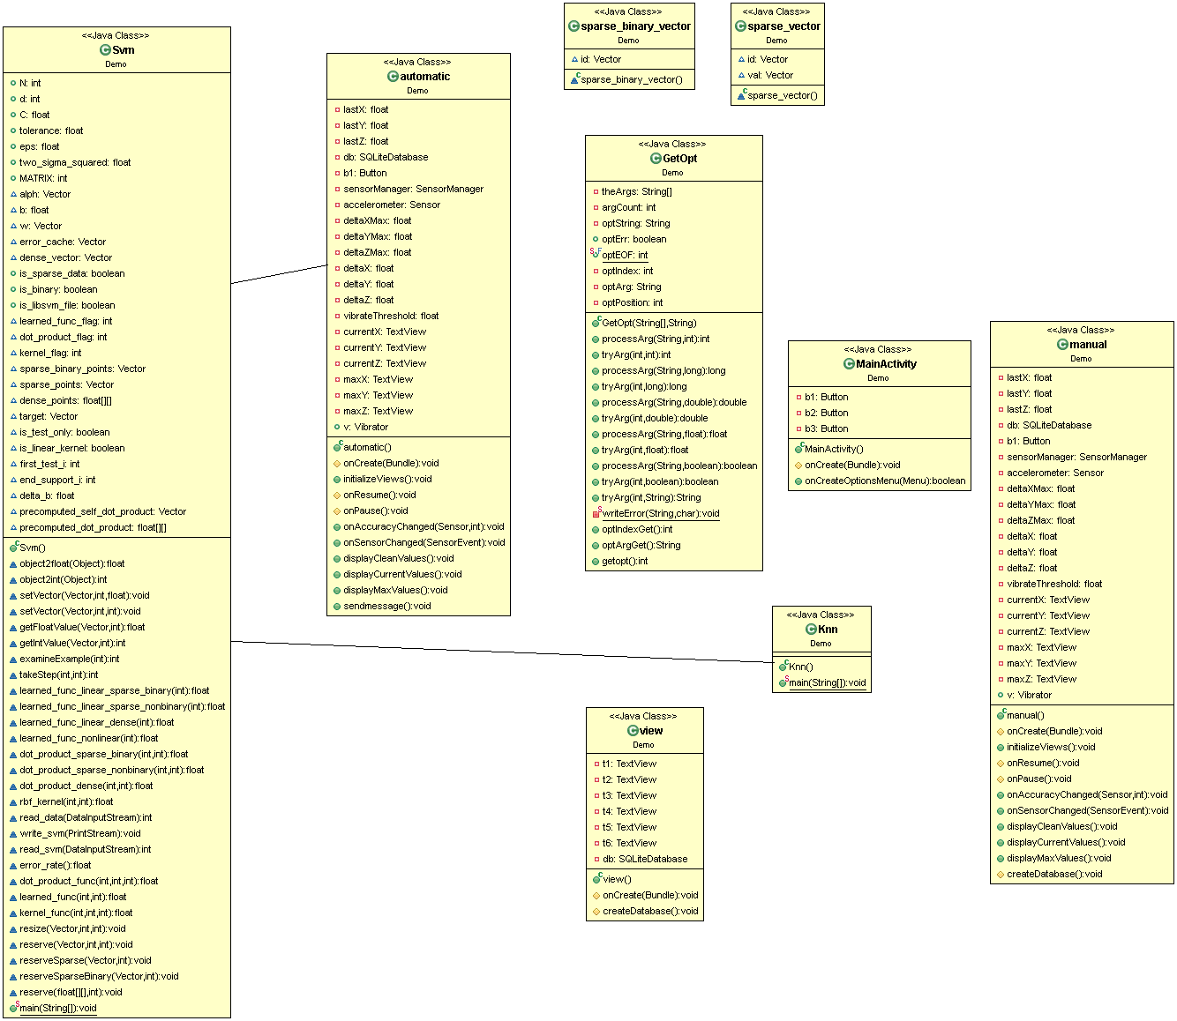
Fig 4.2 Class Diagram
Description:
The above class diagram shows the association among different classes. For doing the manual and automatic phases of our project we use SVM and KNN which is shown in the above figure 3.2 through association.

4.4.2 Use case diagram
It shows a set of use cases and actors and their relationships. These diagrams illustrate the static use case view of a system and are important in organization and modeling the behaviors of a system.
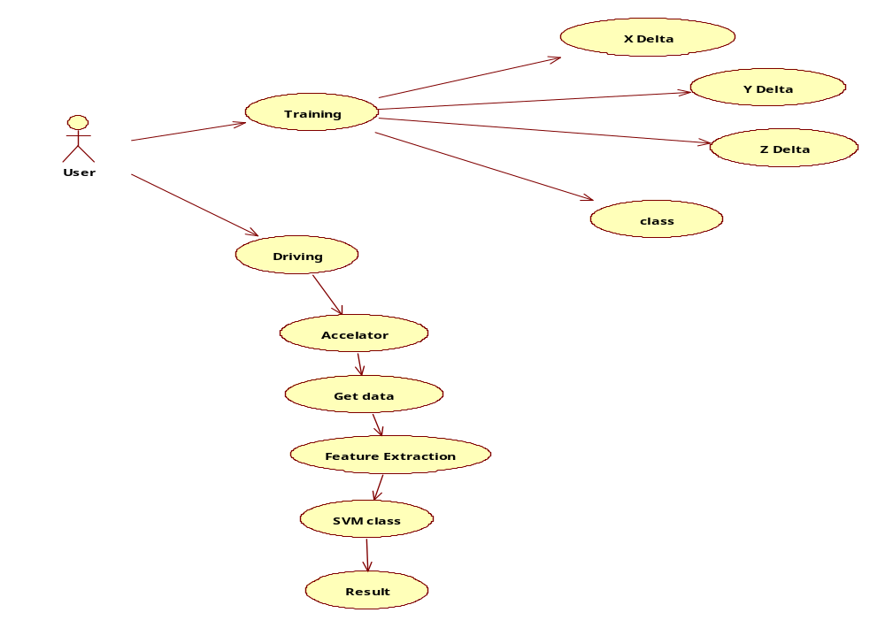
Fig 4.3 Use case Diagram
Description:
In the training phase we collect the data from some users and train them by a classification model by calculating X delta, Y delta, Z delta. Then we get the data from driving phase, extract the features and then produce the result which is shown in the above Fig 4.3

4.4.3 SEQUENCE DIAGRAM
A Sequence Diagram in Unified Modeling Language (UML) is a kind of interaction diagram that shows how process operates with one another and in what order. It is a constructer of a Message Sequence Chart.
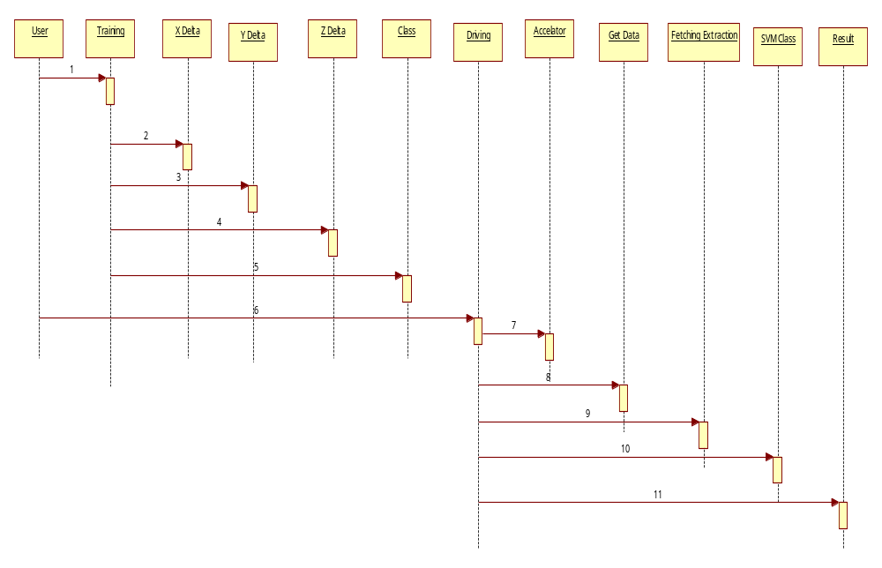
Fig 4.4 Sequence Diagram
Description:
The Fig 3.4 shows the sequence of actions in our project which include collecting data set , calculating X delta, Y delta, Z delta and generating a model which extract the features from the data collected in driving phase from the user(driver).

4.4.4 COLLABORATION DIAGRAM
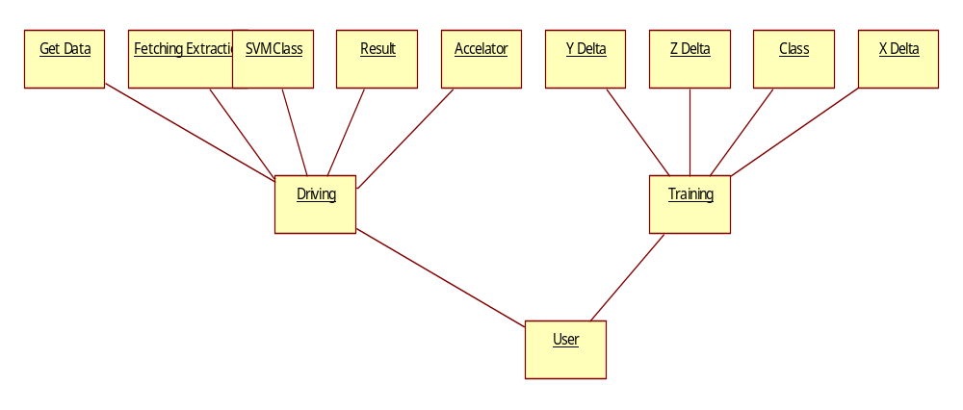
Fig .4.5 Collaboration Diagram .
4.4.5 ACTIVITY DIAGRAM
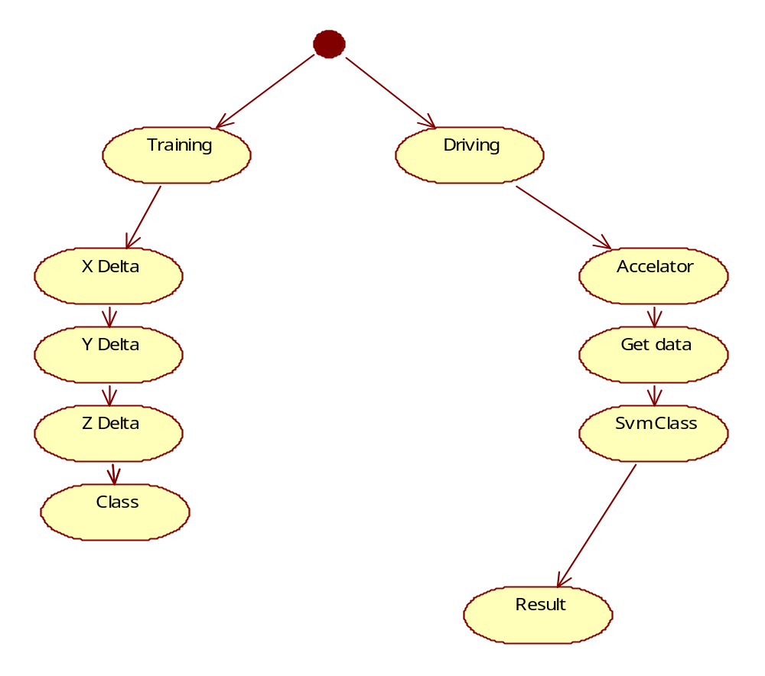
Fig.4.6 Activity Diagram

4.4.6 DATA FLOW DIAGRAM:
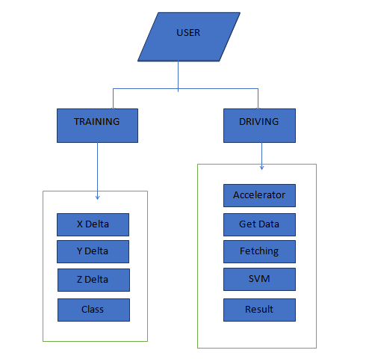
Figure 4.7 Data Flow Diagram
Description:
The above data flow diagram shows the flow of data from user to offline phase and driving phase. The offline phase includes training the data set and the driving phase includes feature extraction from the values collected through accelerometer.

SYSTEM DEVELOPMENT ENVIORNMENT

5. SYSTEM DEVELOPMENT ENVIORNMENT
Android is a Linux-based operating system for mobile devices such as smart phones and tablet computers. It is developed by the Open Handset Alliance led by Google. Android has a large community of developers writing applications ("apps") that extend the functionality of the devices. Developers write primarily in a customized version of Java.

Android architecture
Android consists of a kernel based on the Linux kernel, with middleware, libraries and APIs written in C and application software running on an application framework which includes Java-compatible libraries based on Apache Harmony. Android uses the Dalvik virtual machine with just-in-time compilation to run Dalvik dex-code (Dalvik Executable), which is usually translated from Java bytecode.
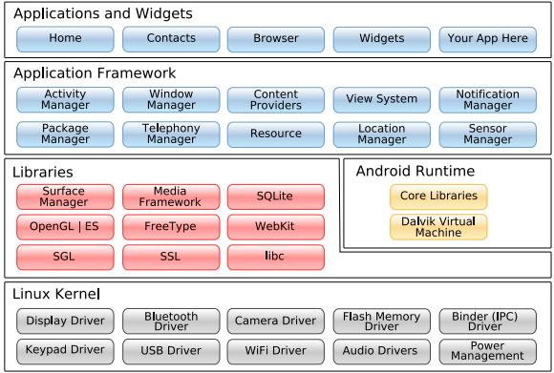
Figure.5.1.Android Architecture

Application Framework
By providing an open development platform, Android offers developers the ability to build extremely rich and innovative applications. Developers are free to take advantage of the device hardware, access location information, run background services, set alarms, add notifications to the status bar, and much, much more.
Developers have full access to the same framework APIs used by the core applications. The application architecture is designed to simplify the reuse of components; any application can publish its capabilities and any other application may then make use of those capabilities (subject to security constraints enforced by the framework). This same mechanism allows components to be replaced by the user.

Libraries
Android includes a set of C/C++ libraries used by various components of the Android system. These capabilities are exposed to developers through the Android application framework. Some of the core libraries are listed below:
- System C library - a BSD-derived implementation of the standard C system library (libc), tuned for embedded Linux-based devices
- Media Libraries - based on PacketVideo's OpenCORE; the libraries support playback and recording of many popular audio and video formats, as well as static image files, including MPEG4, H.264, MP3, AAC, AMR, JPG, and PNG
- Surface Manager - manages access to the display subsystem and seamlessly composites 2D and 3D graphic layers from multiple applications
- LibWebCore - a modern web browser engine which powers both the Android browser and an embeddable web view
- SGL - the underlying 2D graphics engine
- 3D libraries - an implementation based on OpenGL ES 1.0 APIs; the libraries use either hardware 3D acceleration (where available) or the included, highly optimized 3D software rasterizer
- FreeType - bitmap and vector font rendering
- SQLite - a powerful and lightweight relational database engine available to all applications.

Linux Kernel
Android relies on Linux version 2.6 for core system services such as security, memory management, process management, network stack, and driver model. The kernel also acts as an abstraction layer between the hardware and the rest of the software stack.

Sample code

6. Sample code
Code for Creating Buttons and Corresponding Actions:
protected void onCreate(Bundle savedInstanceState) {
super.onCreate(savedInstanceState);
setContentView(R.layout.activity_main);
b1=(Button)findViewById(R.id.button1);
b2=(Button)findViewById(R.id.button2);
b3=(Button)findViewById(R.id.button3);
b1.setOnClickListener(new OnClickListener() {
public void onClick(View v) {
// TODO Auto-generated method stub
Intent login=new Intent(getApplicationContext(),manual.class);
startActivity(login);
}
});
b2.setOnClickListener(new OnClickListener() {
public void onClick(View v) {
Intent login=new Intent(getApplicationContext(),automatic.class);
startActivity(login);
}
});
b3.setOnClickListener(new OnClickListener() {
public void onClick(View v) {
Intent login=new Intent(getApplicationContext(),manual.class);
startActivity(login);
}
});
}

Code For Adding Sensors To The Application:
protected void onCreate(Bundle savedInstanceState) {
super.onCreate(savedInstanceState);
setContentView(R.layout.automatic);
initializeViews();
sensorManager = (SensorManager) getSystemService(Context.SENSOR_SERVICE);
if (sensorManager.getDefaultSensor(Sensor.TYPE_ACCELEROMETER) != null) {
// success! we have an accelerometer
accelerometer = sensorManager.getDefaultSensor(Sensor.TYPE_ACCELEROMETER);
sensorManager.registerListener(this, accelerometer, SensorManager.SENSOR_DELAY_NORMAL);
vibrateThreshold = accelerometer.getMaximumRange() / 2;
} else {
// fai! we dont have an accelerometer!
}

Code For Creating Text Views:
protected void onCreate(Bundle savedInstanceState) {
super.onCreate(savedInstanceState);
setContentView(R.layout.view);
createDatabase();

t1=(TextView)findViewById(R.id.textView1);
t2=(TextView)findViewById(R.id.textView2);
t3=(TextView)findViewById(R.id.textView3);
t4=(TextView)findViewById(R.id.textView4);
t5=(TextView)findViewById(R.id.textView5);
t6=(TextView)findViewById(R.id.textView6);
Cursor c=db.rawQuery("SELECT count(cno) FROM drives where cno ='WAVE'", null);
int count=0;
if(c.moveToNext())
{
String d=t1.getText().toString()+c.getString(0);
t1.setText(d);
}

SYSTEM TESTING

7. SYSTEM TESTING
7.1 INTRODUCTION

Testing is the debugging program is one of the most critical aspects of the computer programming triggers, without programming that works, the system would never produce an output of which it was designed.

Testing is best performed when user development is asked to assist in identifying all errors and bugs. The sample data are used for testing. It is not quantity but quality of the data used the matters of testing. Testing is aimed at ensuring that the system was accurately an efficiently before live operation commands.

Testing objectives:

The main objective of testing is to uncover a host of errors, systematically and with minimum effort and time. Stating formally, we can say, Testing is a process of executing a program with intent of finding an error.

A successful test is one that uncovers an as yet undiscovered error.
- A good test case is one that has probability of finding an error, if it exists.
- The test is inadequate to detect possibly present errors.
- The software more or less confirms to the quality and reliable standards.

7.2 Levels of Testing:
Client needs acceptance testing

Requirements system testing

Design integration testing

Code unit testing

Code testing:

This examines the logic of the program. For example, the logic for updating various sample data and with the sample files and directories were tested and verified.

Specification Testing:

Executing this specification starting what the program should do and how it should performed under various conditions. Test cases for various situation and combination of conditions in all the modules are tested.
Integration Testing:
Data can be lost across an interface, one module can have an adverse effort on the other sub functions, when combined, may not produce the desired major functions. Integrated testing is the systematic testing for constructing the uncover errors within the interface. The testing was done with sample data. The developed system has run successfully for this sample data. The need for integrated test is to find the overall system performance.
Output testing:
After performance of the validation testing, the next step is output testing. The output displayed or generated by the system under consideration is tested by asking the user about the format required by system. The output format on the screen is found to be correct as format was designed in the system phase according to the user needs. Hence the output testing does not result in any correction in the system.
7.3 Testing Strategies
A Strategy for software testing integrates software test cases into series of well planned steps that results in the successful construction of software. Software testing is a broader topic for what is referred to as Verification and Validation. Verification refers to the set of activities that ensure that the software correctly implements a specific function. Validation refers the set of activities that ensure that the software that has been built is traceable to customer’s requirements.

Unit testing:

In the unit testing we test each module individually and integrate with the overall system. Unit testing focuses verification efforts on the smallest unit of software design in the module. This is also known as module testing. The module of the system is tested separately. This testing is carried out during programming stage itself. In the testing step each module is found to work satisfactorily as regard to expected output from the module. There are some validation checks for fields also. For example the validation check is done for varying the user input given by the user which validity of the data entered. It is very easy to find error debut the system.

Each Module can be tested using the following two Strategies:
- Black Box Testing
- White Box Testing

BLACK BOX TESTING
Black box testing is a software testing techniques in which functionality of the software under test (SUT) is tested without looking at the internal code structure, implementation details and knowledge of internal paths of the software. This type of testing is based entirely on the software requirements and specifications.
In Black Box Testing we just focus on inputs and output of the software system without bothering about internal knowledge of the software program.
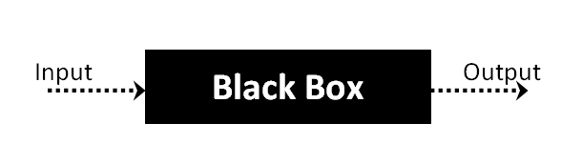
The above Black Box can be any software system you want to test. For example : an operating system like Windows, a website like Google ,a database like Oracle or even your own custom application. Under Black Box Testing, you can test these applications by just focusing on the inputs and outputs without knowing their internal code implementation.

Black box testing - Steps
Here are the generic steps followed to carry out any type of Black Box Testing.
- Initially requirements and specifications of the system are examined.
- Tester chooses valid inputs (positive test scenario) to check whether SUT processes them correctly. Also some invalid inputs (negative test scenario) are chosen to verify that the SUT is able to detect them.
- Tester determines expected outputs for all those inputs.
- Software tester constructs test cases with the selected inputs.
- The test cases are executed.
- Software tester compares the actual outputs with the expected outputs.
- Defects if any are fixed and re-tested.

Types of Black Box Testing
There are many types of Black Box Testing but following are the prominent ones -
- Functional testing – This black box testing type is related to functional requirements of a system; it is done by software testers.
- Non-functional testing – This type of black box testing is not related to testing of a specific functionality, but non-functional requirements such as performance, scalability, usability.
- Regression testing – Regression testing is done after code fixes, upgrades or any other system maintenance to check the new code has not affected the existing code.
WHITE BOX TESTING
White Box Testing is the testing of a software solution's internal coding and infrastructure. It focuses primarily on strengthening security, the flow of inputs and outputs through the application, and improving design and usability. White box testing is also known as clear, open, structural, and glass box testing.
It is one of two parts of the "box testing" approach of software testing. Its counter-part, blackbox testing, involves testing from an external or end-user type perspective. On the other hand, Whitebox testing is based on the inner workings of an application and revolves around internal testing. The term "whitebox" was used because of the see-through box concept. The clear box or whitebox name symbolizes the ability to see through the software's outer shell (or "box") into its inner workings. Likewise, the "black box" in "black box testing" symbolizes not being able to see the inner workings of the software so that only the end-user experience can be tested
White box testing involves the testing of the software code for the following:
- Internal security holes
- Broken or poorly structured paths in the coding processes
- The flow of specific inputs through the code
- Expected output
- The functionality of conditional loops
- Testing of each statement, object and function on an individual basis
The testing can be done at system, integration and unit levels of software development. One of the basic goals of whitebox testing is to verify a working flow for an application. It involves testing a series of predefined inputs against expected or desired outputs so that when a specific input does not result in the expected output, you have encountered a bug.
Performance of White Box Testing
To give you a simplified explanation of white box testing, we have divided it into two basic steps. This is what testers do when testing an application using the white box testing technique:
STEP 1) UNDERSTAND THE SOURCE CODE
The first thing a tester will often do is learn and understand the source code of the application. Since white box testing involves the testing of the inner workings of an application, the tester must be very knowledgeable in the programming languages used in the applications they are testing. Also, the testing person must be highly aware of secure coding practices. Security is often one of the primary objectives of testing software. The tester should be able to find security issues and prevent attacks from hackers and naive users who might inject malicious code into the application either knowingly or unknowingly.
Step 2) CREATE TEST CASES AND EXECUTE
The second basic step to white box testing involves testing the application’s source code for proper flow and structure. One way is by writing more code to test the application’s source code. The tester will develop little tests for each process or series of processes in the application. This method requires that the tester must have intimate knowledge of the code and is often done by the developer. Other methods include manual testing, trial and error testing and the use of testing tools as we will explain further on in this article.
System testing:
Once the individual module testing is completed, modules are assembled and integrated to perform as a system. The top down testing, which began from upper level to lower level module, was carried out to check whether the entire system is performing satisfactorily.
There are three main kinds of System testing:
- Alpha Testing
- Beta Testing
- Acceptance Testing
Alpha Testing:
This refers to the system testing that is carried out by the test team with the Organization.
Beta Testing:
This refers to the system testing that is performed by a selected group of friendly customers.
Acceptance Testing:
This refers to the system testing that is performed by the customer to determine whether or not to accept the delivery of the system.
Test plan:
The test-plan is basically a list of test cases that need to be run on the system. Some of the test cases can be run independently for some components (report generation from the database, for example, can be tested independently) and some of the test cases require the whole system to be ready for their execution. It is better to test each component as and when it is ready before integrating the components. It is important to note that the test cases cover all the aspects of the system (i.e., all the requirements stated in the RS document).

SCREEN SHOTS

8. SCREEN SHOTS
8.1. Application in Smart Phone:
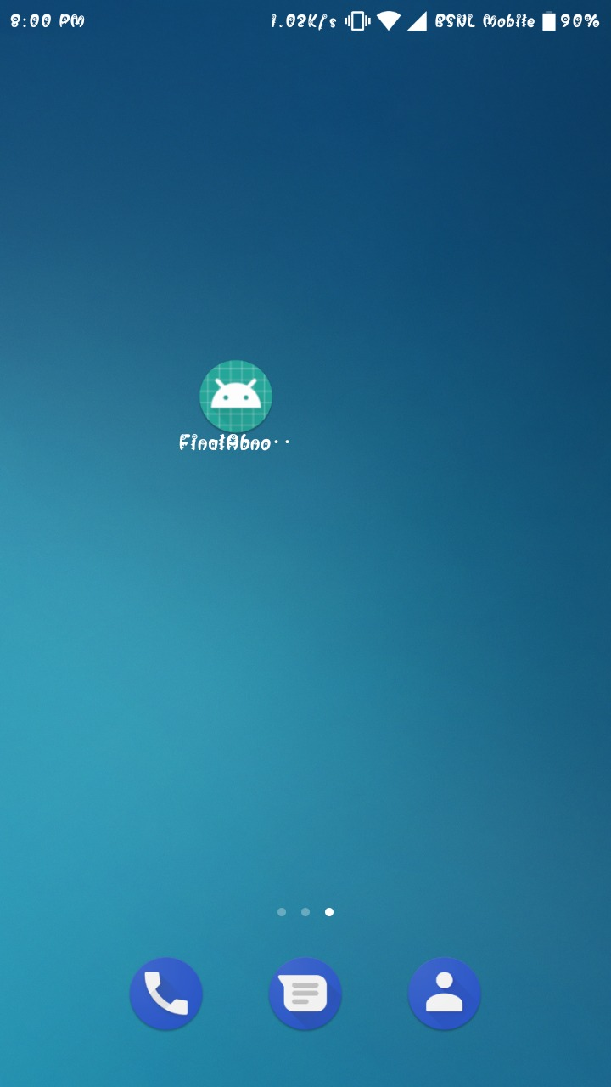
Figure 8.1.Application preview
Description:
The above figure 7.1 shows how our application will be visible in the smart phone

8.2. Overview of Application:
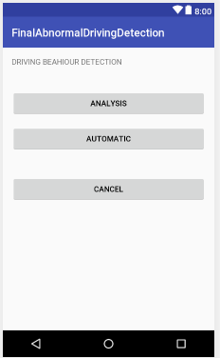
Figure 8.2 Overview of application
Description:
Figure 7.2 shows the overview of our application which contains three buttons for analysis, automatic and to exit from the application. Analysis button for analyzing the driving behaviors, automatic for generating alerts, and cancel to exit the application.

8.3. View of Analysis phase:
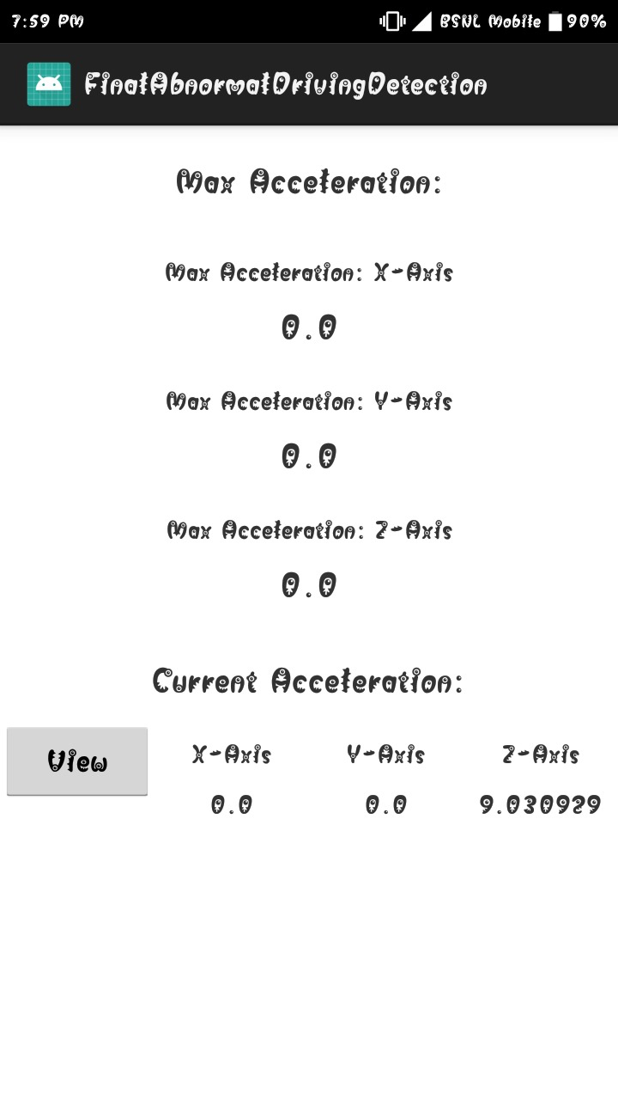
Figure 8.3.Analysis Phase
Description:
On clicking the analysis phase you will the screen as in the above figure 7.3 which records the current acceleration of x, y and z axes.

8.4 Result of Analysis Phase:

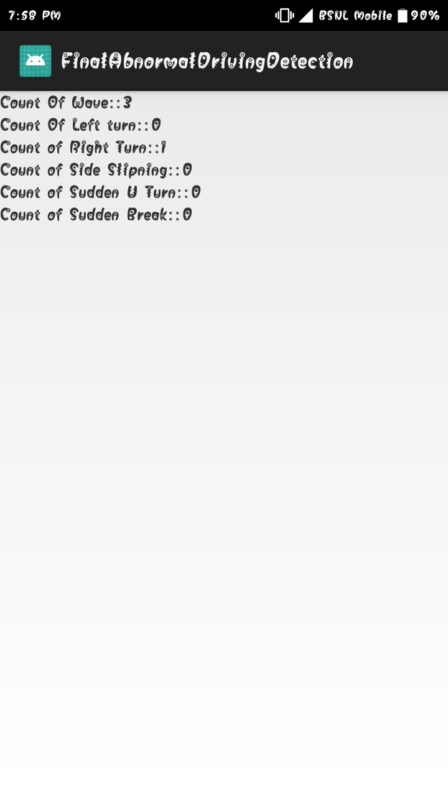
Figure 8.4.Result of analysis phase
Description:
On clicking the analysis button you will get the output as the count for every abnormal behavior that has encountered during driving.

8.5. View in Automatic Phase
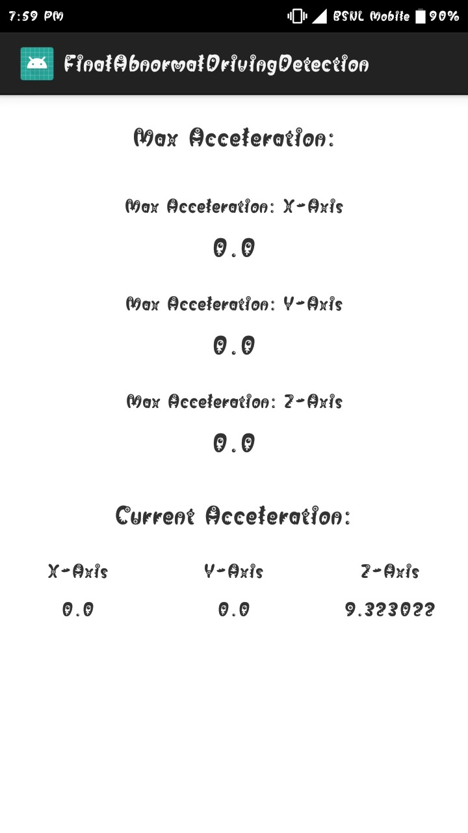
Figure 8.5.Automatic Phase
Description:
On clicking the automatic phase you will the screen as in the above figure 7.5 which records the current acceleration of x, y and z axes.
8.6. Alert Screen

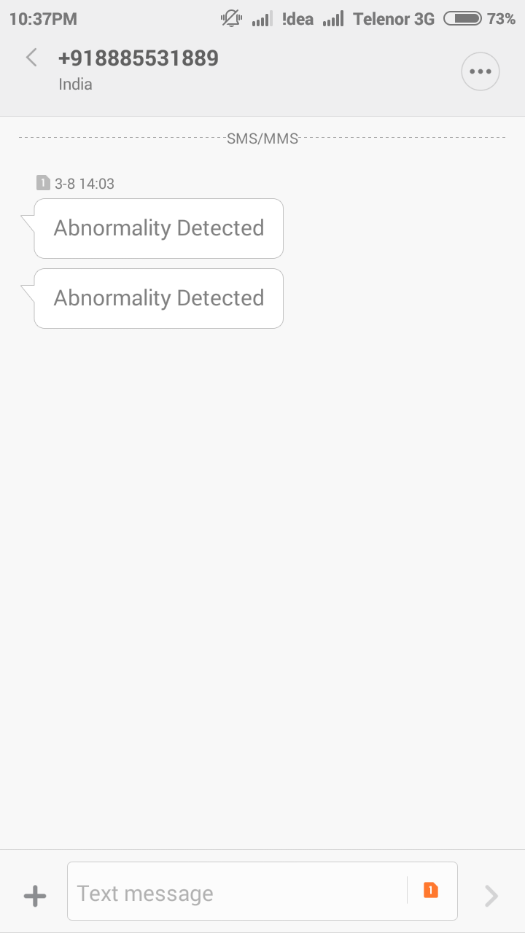
Figure 8.6 Result of Automatic Phase
Description:
The result of automatic phase is to generate a alert message to the specified number. Figure 7.6 shows the alert message sent to the specified number.

CONCLUSION

8. CONCLUSION
We addressed the problem of performing abnormal driving behaviors detection (coarse-grained) and identification (fine-grained) to improve driving safety. In this different problems are reviewed from the existing work on smart phone driver behavior detection. Some problems are like to early detect abnormal driving status (e.g., drunk, fatigue, and drowsy) and those representation learning problems. Another problem is the lane positioning problems such as drifting and swerving. The second category is related to speed control problems such as sudden acceleration or erratic braking. All these problems are resolved win the future with the help of SVM to improve the results.

FUTURE SCOPE

9. FUTURE SCOPE
This project has a wide scope for development by including some extra features that is if the results of the monitoring could be passed back to a central server, they could be used by the police to detect drunken-driving automatically or Vehicle Insurance Company to analyze the policyholders’ driving habits.
Some important features are:

- Impact of Training Set Size
- Impact of Traffic Condition
- Impact of Road Type
- Impact of Smartphone Placement
- Impact of Smartphone Sensors’ Sampling Rate

BIBLOGRAPHY

10. BIBLOGRAPHY
- World.Health.Organisation. The top ten causes of death. [Online]. Available http://www.who.int/mediacentre/factsheets/fs310/en/
- C. Saiprasert and W. Pattara-Atikom, “Smartphone enabled dangerous driving report system,” in Proc. HICSS, 2013, pp. 1231–1237.
- M. V. Yeo, X. Li, K. Shen, and E. P. Wilder-Smith, “Can svm be used for automatic eeg detection of drowsiness during car driving?” Elsevier Safety Science, vol. 47, pp. 115–124, 2009.
- S. Al-Sultan, A. H.Al-Bayatti, and H. Zedan, “Context-aware driver behavior detection system in intelligent transportaion system,” IEEE Trans. on Vehicular Technology, vol. 62, pp. 4264–4275, 2013.
- J. Paefgen, F. Kehr, Y. Zhai, and F. Michahelles, “Driving behaviour analysis with smartphones: insights from a controlled field study.”
- Y. Wang, J. Yang, H. Liu, Y. Chen, M. Gruteser, and R. P. Martin, “Sensing vehicle dynamics for determining driver phone use,” in Proc. ACM MobiSys, 2013.
- H. Han, J. Yu, H. Zhu, Y. Chen, J. Yang, Y. Zhu, G. Xue, and M. Li, “Senspeed: Sensing driving conditions to estimate vehicle speed in urban environments,” in Proc. IEEE INFOCOM, 2014.
- S. Reddy, M. Mun, J. Burke, D. Estrin, M. Hansen, and M. Srivastava, “Using mobile phones to determine transportation modes,” ACM Trans. on Sensor Networks, vol. 6, no. 13, 2010.
- J. Dai, J. Teng, X. Bai, and Z. Shen, “Mobile phone based drunk driving detection,” in Proc. PervasiveHealth, 2010, pp. 1–8.
- M. Fazeen, B. Gozick, R. Dantu, M. Bhukuiya, and M. C.Gonzalez, “Safe driving using mobile phones,” IEEE Trans. on Intelligent Transportation Systems, vol. 13, pp. 1462–1468, 2012.
- U.S.NHTSA. The visual detection of dwi motorists. [Online] Available: http://www.shippd.org/Alcohol/dwibooklet.pdf
- D. Lee, S. Oh, S. Heo, and M. Hahn, “Drowsy driving detection based on the driver’s head movement using infrared sensors,” in Proc. IEEE ISUC, 2008, pp. 231–236.

